CONFIDENTIAL · INTERNAL WORKING PAPER
PULSE
Architecture of the Pulse Framework
Continuous Authentication & Identity Assurance — Component Architecture and Design Rationale
AffirmedID · AffirmedId.com
Not for external distribution, August 2026

Contents

Contents 2
Philosophy 4
Foundational Principles 4
Architecture Objectives 4
The Problem with Today’s Security 5
Architecture Diagram 5
Architectural Objectives 7
Architectural Goals 7
Identity and Trust Objectives 7
Operational Objectives 7
Component Architecture 8
Pulse, when deployed as IdP Provider 8
Component Summaries — Principal IdP Configuration 8
Pulse, when deployed as an Addon Security Service 11
Discovery Sequence 11
Three Foundational Cornerstones of Pulse CA 12
1. FIDO2, the Bedrock of Phishing Resistant Authentication 12
2. TriNet, the Original 3-Point Security Assurance Methodology 12
Components 12
Dependencies 12
3. Basis of Trust & Policy-based Decision and Enforcement 13
Threat-Class Map 14
Architecture Narrative 15
Design Goal Statement — Pulse Framework Overall 15
Pulse Framework 15
Design Goal Statement — Pulse AutthZEN Enforcement Engine 16
Purpose 16
Design Goals 16
Design Goal Statements - Attack and Detection Scenarios 17
Deployment Modalities 18
Pulse Component Specifics 18
Pulse API 18
Auth 19
Connect 20
Reflex, An Endpoint Security Service 20
The Reflex Architecture 21
Reflex, Trust Model 21
Reflex, Core Architecture 22
Endpoint Security 26
Multiuser, Multiple Agent per User, Flow Diagram 26
Glossary 28

Philosophy
Authentication is an event. Trust is a long-term, continuously evaluated session state. Securing the session is the objective — securing authentication is only one part of doing so.
This principle underlies every design decision described in this document. Pulse does not treat login as the finish line; it treats login as the first of many checkpoints in a session that is monitored, scored, and enforced against, continuously, until logout.

Foundational Principles
- User accountability and authorization, continuously evaluated throughout the session, form the basis of trust for the session itself, with any changes in trust acted upon in a timely manner;
- where non-human identities act, policy assigns an accountable user as their stand-in, and their authority is bounded by that user’s;
- process accountability and authorization within the endpoint are the basis for enforcing policy and access;
- no process may execute unless, it is verifiably attributable to an accountable user, directly, through trusted lineage, or through a policy-assigned stand-in; processes failing attribution are paused pending policy-scoped evaluation;
- session security exists where user intent and process identity are verifiably bound, so that each process action is attributable to an authorized user purpose;
- when policy-scoped evaluation fails, response is proportionate to the failure: processes under the user’s trust umbrella, including those of their non-human stand-ins, are restricted or suspended pending notification and step-up verification, or terminated where policy requires; and
- these principles are achieved without unduly burdening the user on whom the session depends, within defined risk boundaries, recognizing that friction invites circumvention.

Architecture Objectives
Identity is core to Pulse architecture;
- Identity originates from the human user, represented by a combination of behaviors and knowledge (PIN) and their possession of a phishing resistant device, both being attested to as part of a single registration process.
- User Identity is affirmed by verification of their behavior-based PIN and their physical possession of the registered phishing resistance device. Together, though attested to separately, they form a trust bond on which the rest of the Pulse framework relies. User -> cryptographic device -> framework
- User identity becomes an immutable fact with reassurance of it provided on a continuing basis.
End-to-end trust;
- Every endpoint within the framework is cryptographically assured by phishing resistant FIDO2 and / or as a demonstrated cryptographic proof-of-possession using OAuth2, each verified as a condition of exchange.
- Payload encryption using post quantum cryptography is employed in all TLS exchanges between framework endpoints.
Closing the gap;
- Cryptographically coupling User identity to that of the Agent.
- Provide accountability based on those cryptographic identities.
- Do so by monitoring user identity trust scores:
  - User identity itself
  - User presence and participation
  - User proximity to agent activities
- Localized AuthZEN provide agent level monitoring
  - COAZ-MCP following standards adoptions

The Problem with Today’s Security
Every organization that provides access to digital services faces the same hidden vulnerability: authentication happens once, at the point of login, and then stops. From that moment on, whether the session lasts 10 minutes or 10 hours, the system has no reliable way of knowing whether the person who logged in is still the person in control.
This gap is where modern attacks occur. Authorization token handed off to bad actor following successful MFA. Stolen credentials used mid-session. Devices handed to an unauthorized person. Employees moving to unexpected locations. Compromised phones continue to hold active access tokens. Traditional security tools have no answer to any of these scenarios once the login ceremony is complete.
As AI-powered automation becomes central to enterprise operations, the stakes increase further. AI agents frequently run for hours without direct human interaction, making decisions and accessing sensitive data on the user's behalf. Worse yet, the agentic AI tasks it spins off with equal access to perform tasks absent accountability or awareness. A compromised session that feeds an autonomous agent can cause far greater harm than a compromised human session alone.
These aren't hypothetical risks. The 2024 discovery of 17 billion stolen session cookies exposed session hijacking as an attack class in its own right, by 2025 Obsidian Security reports it was behind 87% of successful attacks that followed a valid MFA login. And in November 2025, exploitation of Gainsight's OAuth integrations compromised 200+ Salesforce customer environments, not because anyone's login was compromised, but because nothing was watching what happened after it.

Architecture Diagram
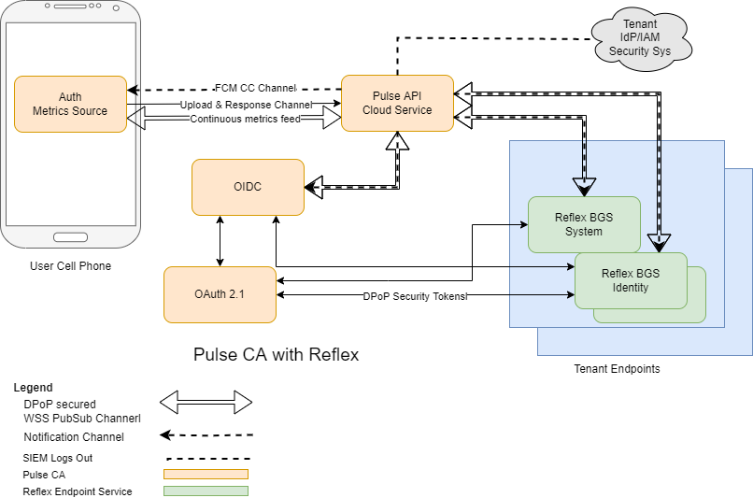
The diagram shown here is architectural view of of Pulse and all its components. Briefly describe here, more indepth later in this doc:</p>
- Auth – the authenticator and source of continuous monitoring metrics app on the users cell phone.
- Pulse API – the cloud service responsible for orchestrating all other parts
- OIDC – the OpenID Connect provider service (a SAML provider is also available)
- OAuth 2.1 – an implementation of OAuth 2.1 with extensions
- Reflex – a 2 part endpoint security service installed on tenant endpoint devices
Legend:
- DPoP secured WSS PubSub channels exist between the API and each component.
  - Connection not shown for OAuth 2.1 to reduce picture clutter
  - Special note for Auth where it’s use is limited to active continuous monitoring sessions
  - PubSub temonanlogy meaning a publisher and subscriber service where in the API is always the publisher
- Notification channel, a subscription message notification service
- SIEM out, sends logs to tenants electing to receive them
- Pulse CA, components
- Reflex endpoint service, optional components instaled on one or more tenant endpoint devices

Architectural Objectives
Legacy IdP and IAM solutions date to a time when a “detect and report” philosophy was considered good security hygiene. Pulse CA aligns with a present-day “detect and prevent — and report too” philosophy. A subtle distinction, but one worth deliberate consideration in any evaluation of the architecture. When considering a move to the culture of detect and prevent the choices were patch and pray or rip-and-replace. Pulse architecture and design brings a third perhaps more attractive option, to retain and addon the a Pulse like monitoring service.
The Pulse architecture is designed as a unified authentication, identity assurance, and session security platform that continuously establishes, evaluates, and enforces trust throughout the lifecycle of every authenticated session. The architecture targets two deployment models built from a common set of components:
- Principal Identity Provider (IdP) — deployed independently, alongside an existing IAM, or behind an existing IAM.
- Add-on security service — deployed alongside an existing IdP or IAM service.

Architectural Goals
- Unified components by design;
- Integrated by default;
- Standards-based where practical
- Standards-aligned where no applicable standard exists;
- Secure-by-design, using established industry best practices; and
- Engineered through automated verification and secure development practices

Identity and Trust Objectives
Pulse provides continuous assurance of:
- User identity;
- Device identity;
- User presence and engagement;
- Session integrity;
- Full session accountability and auditability;
- Dynamic trust evaluation throughout an authenticated session; and
- End-to-end, login-to-logout phishing resistance.

Operational Objectives
Alongside enterprise-grade security, Pulse is designed to deliver and maintain:
- A frictionless user experience;
- Simplified integration for relying parties;
- Ease of deployment and operation;
- Scalable, standards-based interoperability; and
- Flexibility to meet differing client needs.

Component Architecture
The figures below introduce the Pulse component set and the two supported deployment methods. Each figure placeholder is clearly marked for insertion of the corresponding final graphic.

Pulse, when deployed as IdP Provider
As the Principal Identity Provider and Continuous Authentication (CA) and Identity Authorization service, Pulse provides phishing-resistance enforcement for both authentication and session monitoring:
- Auth app's Multi-Factor Authentication (MFA)
- Connect, Pulse's OIDC provider service, enhances security by detecting and neutralizing device-code phishing attacks and by including:
  - Device-bound WebAuthn-compliant FIDO2 assertions, augmented with Auth's PIN-behavior-based identity assertion, or
  - Passkey FIDO2, augmented with Auth's PIN-behavior-based identity assertion
- Step-up authentication, triggered by the Policy Enforcement Point (PEP) service of OIDC or Reflex (configuration-dependent) and fulfilled by the Auth app on the user's cell phone device
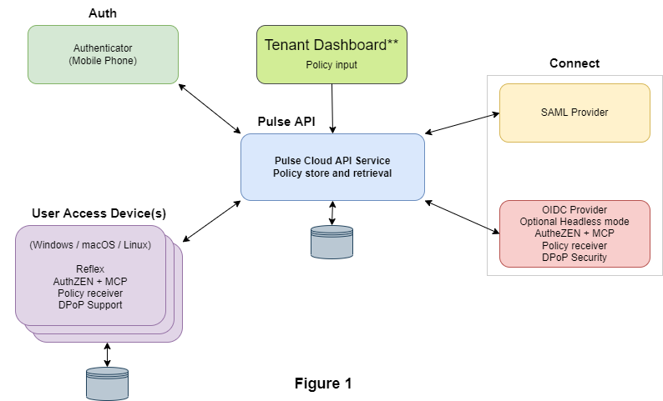

** Work in progress, completion Q4 2026

Component Summaries — Principal IdP Configuration
Auth Authenticator cell phone application
- MFA aligned with NIST AAL3
- Identity recognition (proofing) using PIN-behavior-based methods
- WebAuthn FIDO2 authentication
- Continuous monitoring based on cell phone sensor devices
- Source of identity and device metrics supplied to the Policy Decision Point (PDP)
- Employs FIDO2 DA for external non-authentication Pulse API exchanges
- Implements DPoP as a client

Connect — OIDC Provider Standards-compliant OpenID Connect / OAuth 2.0
- Standards-compliant implementation of OpenID Connect (OIDC), inclusive of OAuth 2.0 support
- Adapted for continuous-monitoring environments through added functionality
- Supports session accountability in both user and non-user environments; supports MFA Auth and SFA Passkey
- Provides an AuthZEN endpoint for deployments unable to use Reflex — latency is comparable to Reflex's, though the design goal is for Reflex to remain the faster path
- Implements DPoP as a client

Connect — SAML Provider Standards-compliant Security Assertion Markup Language 2.0
- Standards-compliant implementation of SAML 2.0
- Substantially enhanced, as with OIDC, to meet the needs of a continuous-authentication service
- Provides Single Sign-On (SSO) session accountability in a continuous-monitoring environment through added functionality
- Implements DPoP as a client

Reflex Access-device background service (Windows, macOS, Linux)
- Adapts the access device — its apps, agents, and services — to the continuously-monitored environment goal
- TriNet authentication and session assurance, based on a three-point security-assurance model
- AuthZEN policy-endpoint tools, based on analysis of Auth-supplied and Pulse-API-delivered metrics
- Brings continuous-authentication technology to AI agent and agentic deployments through its AuthZEN
- Implements DPoP as a client

Commander Tenant administration dashboard
- Used by tenant administrators for administration, monitoring, and maintenance of a Pulse CA deployment
- Covers deployment configuration and ongoing maintenance tasks
- Implements DPoP as a client

Pulse API Cloud orchestration service
- Multiple controllers, each responsible for one of the components above
- Includes cloud-based FIDO2 Client functionality and federated user accounts
- Implements DPoP as a server

OAuth 2.0
- OAuth 2.0 provider service for internal use only
- Used exclusively for all exchanges between Pulse API and other framework applications
- Implements FIDO2 DA client

Pulse, when deployed as an Addon Security Service
As an add-on Continuous Authentication (CA) provider service, Pulse operates in parallel with an existing IdP or IAM, which retains primary responsibility for identity and user authorization. Important characteristics include:
- Pulse as an add-on is compatible with virtually every type of IdP or IAM deployment. A list of known-compatible deployments is available on request.
- The internal Pulse OIDC provider service is available to the relying party for general session management.
- The internal OIDC provider is used in headless authorizations to create CA tracking and authorizing sessions.
- The example configuration shown in Figure 2, aligned with Cisco Duo, illustrates a realistic deployment — it does not imply an exclusive or required pairing.
- The example configuration has a mobile-device dependency, shown also hosting the Pulse Auth sensor and authenticator app. Where the aligned third-party product does not require a mobile device, the user must still have a personal cell phone, or be issued one by the relying party, for Pulse CA to function.
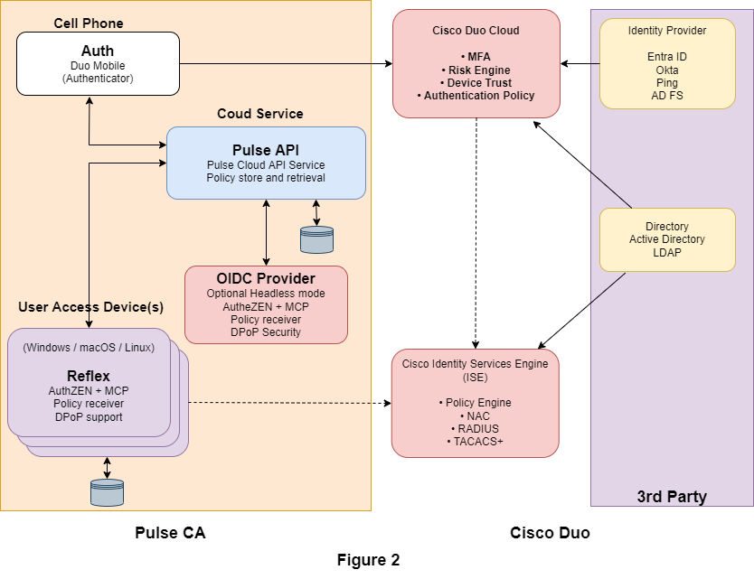
** Work in progress, completion Q4 2026

Discovery Sequence
Discovery of a cell phone device's near-proximity to its user depends on each of the following steps, in order:
- Reflex knows the username of the cell phone device's user, and transfers that as part of a proximity random-nonce token request to the Pulse API.
- Pulse API discovers and accesses the username database record, retrieves the user's cell-phone FCM address, and formats and transmits a single FCM data-only message containing Reflex's request to the device.
- Auth receives and promptly acts on that notification message, translating the provided token to UUID format and publishing it as part of a BLE advertising session.
- Reflex detects the BLE advertisement by UUID recognition or timeout, produces a metric indicative of its findings, and forwards that metric to Pulse API for promotion to monitoring endpoints.
- Reflex ends the proximity-detection session by transmitting an end-advertisement request to Auth via Pulse API, using similar exchange methods.
Securing the proximity-request exchange is indicated in the diagram at Figure 3

Three Foundational Cornerstones of Pulse CA

FIDO2, the Bedrock of Phishing Resistant Authentication
The Pulse OIDC provider only supports login using Auth or Passkey. Both are FIDO2-compliant. Pulse also recognizes that any generally available human-to-machine (H2M) authentication endpoint remains susceptible to phishing attack — which is why Pulse additionally relies on FIDO2 for
- Device Cryptographic Assertion (DA): an out-of-scope application of FIDO2 in which its cryptographic capabilities are used without a user gesture, which is unnecessary where DA is applied. In Pulse documentation this is referred to as FIDO2 DA.
  - Specific claims of use:
  - Based on FIDO2 cryptography
  - Adopts the FIDO2 attestation ceremony
  - Adopts the FIDO2 assertion ceremony
  - Does not support user gesture or user verification (UV)
  - Is not FIDO2-certified

TriNet, the Original 3-Point Security Assurance Methodology
Triad Security Network (TriNet) is a network-security architecture similar to the caBLE (cloud-assisted Bluetooth Low Energy) approach announced by Google in April 2019 — but conceived and patent-protected four years earlier. Figure 3 shows an application of TriNet, employed by Reflex to actively verify the near-proximity of a specific cell phone and its user.

Components
- Reflex — installed on the user's access device; one of its responsibilities is detecting and verifying near-proximity of a specific cell phone device and its user, and reporting metrics indicative of its findings.
- Pulse API — the intermediary responsible for transferring a Reflex proximity-check request to a specific cell phone device, and for receiving metrics input and disseminating it to Pulse's monitoring endpoints.
- Auth — the Pulse authenticator app, responsible for receiving and forwarding a UUID token via BLE advertisement from its device's BLE controller.

Dependencies
TriNet has two critical dependencies, both user-controllable and either of which could be disabled. User education on these requirements is out of scope for this document.
- Bluetooth Low Energy (BLE) availability is required on both the user's cell phone device and the access device on which Reflex is deployed.
- FCM/APNS push messaging must be enabled.
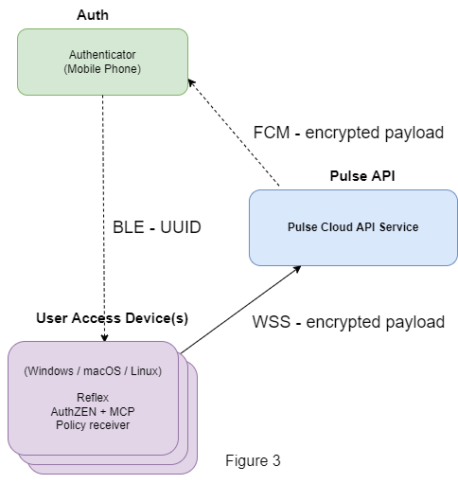
** Work in progress, completion Q4 2026

Basis of Trust & Policy-based Decision and Enforcement
Pulse CA’s source of trust originates mainly in the Auth app on the user’s cell phone. Other inputs originate within the API, OIDC, and Reflex. For example, metrics from OIDC and the controllers within API as well as from Reflex, as the source of truth for active proximity metric, are added to the trust score package as it is passes through the API.
The flow progresses from API to Reflex’s AuthZEN service. Configured policies are applied to metrics by the Policy Decision Point (PDP) creating trust scores. Trust scores proceed from the PDP to the Policy End Point (PEP).
Not shown but also provided are the streaming of trust score metrics and associated decisions to the API SIEM interface for forwarding to configured logging endpoints if any.
Metrics from Auth are updated every 30 seconds. Availability from PEP and AuthZEN are on millisecond scale with a staleness possibility of up to 29 seconds.

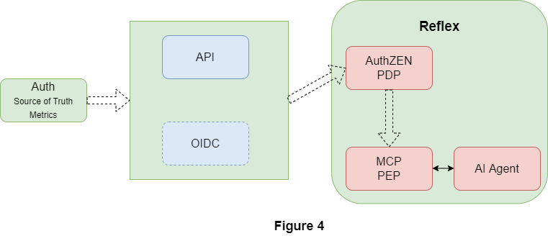
** Work in progress, completion Q4 2026

Threat-Class Map
An architectural intent is that Pulse will detect and prevent or notify potential security events, or to block their occurrence altogether. It’s been suggested OAuth app consent phishing is impossible to prevent, by those unaware of Pulse architecture.

An explicit map of well-known attack classes addressed by Pulse, applicable both when deployed as the primary identity provider and when as an add-on to existing IdP or IAM. Each class is stated plainly as in scope by design, out of scope by design choice, or in scope pending further work — so that a reader does not need to reconstruct the position by cross-referencing separate documents.
Attack Class | Scope | Pulse Mitigation
Device-code phishing | In scope by design | Pulse OIDC exposes no ~/oauth2/v2.0/devicecode API, so there is no endpoint to exploit. This holds when Pulse is the primary IdP, and is optional for relying-party use when Pulse is deployed as an add-on.
Consent / push-fatigue phishing | In scope by design | Every notification-channel use is prefaced by alignment and validation of the requesting identity against the device-associated username record and its active status; undecryptable payloads are refused; and the user's “Block” + Cancel action promotes permanent blocking of FCM/APNS notifications by domain and IP.
OAuth app consent phishing | In scope by design | The receiving endpoint must complete a FIDO2 DA device assertion before authorization codes, tokens, and refresh tokens are delivered to it. This same mechanism also prevents device-code phishing, token-as-a-service attacks, MFA bypass via legitimate IdP login, remote token theft, EvilProxy-style reverse-proxy phishing, and ConsentFix-style silent token harvesting.
Adversary-in-the-Middle (AiTM) | In scope by design | Extensive use of FIDO2 and FIDO2 DA phishing resistance, combined with payload encryption that secures data in flight.
Token replay | In scope by design | Addressed by the same controls described under Device-code phishing, above.
Malware | Out of scope | Nether considered or addressed within Pulse architecture.
On-device AuthZEN intercept | In scope by design | As provided by Reflex, implicit intercept prevention as an in-process service.
Off-device AuthZEN intercept | In scope by design | As provided by OIDC’s authentication and access token requirements.
Session cookie theft | In scope by design | In-scope for all exchanges where FIDO2, FIDO2 DA, or DPoP are used.
Orphaned Agents | In scope by design | Detects, reports, and suspends or terminates orphan AI agent processes.
Abandoned Agents | In scope by design | Detects and reports loss of principle presence or authority and suspends or terminates abandoned AI agent processes.
Illegitimate Agents | In scope by design | Detects and reports rogue or illegitimate AI agents and suspends or terminates them.
Endpoint Security – Internal | In scope by design | Employs both mTLS endpoint and DPoP application layer security in all but 2 cases.
Endpoint Security – External | Partial | Auth and Reflex employ FIDSO2 and DPoP application layer security and HTTPS.

Architecture Narrative

Design Goal Statement — Pulse Framework Overall
Architecturally Pulse is as effective at securing sessions in general as it is at securing AI agent sessions. No matter session purpose, by definition a session begins with authentication as part of login and extends to logout. Its focus is on that simple truth. While below we discuss AI centric features such as AuthZEN, the more general security features are equally important. In that regard then:

Pulse Framework
- Pulse API registration is obligatory for all Pulse framework elements:
  - As part of the Auth app installation and registration; and
  - As part of instantiation of each framework element including:
    - OIDC
    - SAML
    - Reflex
    - Tenant Dashboard
    - Admin Dashboard
    - Diagnostic Dashboard
- Phishing resistant authentication is mandatory:
  - Provided by Auth FIDO2 authenticator for login to both OIDC and SAML.
  - Provided by Passkey authenticator for login to OIDC (user’s choice).
  - Provided by Auth for all step-up re-authentication ceremonies.
- Pulse API requires phishing resistance at every human-to-machine boundary:
  - For Auth, phishing resistant FIDO2 registration as part of app registration;
  - For all others, phishing resistant FIDO2 DA registration on first instantiation of services during element registration ceremony including OIDC, SAML, and OAuth 2.1 providers, Reflex, and all dashboard tools; and
  - Use of phishing resistant DPoP (Demonstrating Proof of Possession), RFC 9449, for all messages originating in all Pulse elements, including OIDC, SAML, and OAuth 2.1 providers, Reflex, and all dashboard tools.
- Use of Mutual TLS (mTLS) is required by all elements except Auth for messages that originate from the element.
- Notification message handling by Pulse API:
  - Delivered over FCM for Auth; and
  - Delivered over WSS for all other elements.
- Payload encryption is enforced by Pulse API for all exchanges between it and Auth, Reflex and all dashboards.

Design Goal Statement — Pulse AutthZEN Enforcement Engine

Purpose
Pulse is not an inference engine that happens to touch policy — it is a policy enforcement engine that may use inference as one input among several. That distinction determines everything about where authority lives in the system.
Protocol compliance is not authorization. That AuthZEN permits a request to be structured and transmitted says nothing about whether a human or their employer actually wanted that action taken in that moment. An AI process can infer intent, but inference is a guess — however well-informed — not a decision of record. Pulse exists to close that gap: to ensure consequential actions are gated by an authoritative decision outside the AI's own reasoning, not by the AI's confidence in its own judgment.

Design Goals
- 1. Decision authority lives outside the AI process. The AI may request evaluation and supply context, but it does not compute, interpret, or apply the policy decision itself. The evaluator is a separate, authoritative component the AI cannot reason its way around.
- 2. Enforcement sits at the resource, not in advice. The evaluator must sit at the same layer as the protected action (the AuthZEN server, the API gateway, the resource owner). A judgment the AI can bypass by calling something else directly is not enforcement — it's a suggestion.
- 3. Fail-closed by default. Any failure to obtain a clear, timely decision — timeout, outage, malformed response, ambiguous state — is treated as a denial, never as permission to proceed. Uncertainty blocks; it never waves through.
- 4. Independent, tamper-resistant record of decisions. The evaluator logs its own decisions. The system of record does not depend on the AI's self-reported summary of what happened.
- 5. No path from “judgment” to “override.” Where a hard stop applies, it terminates the flow unconditionally — no retry-around, no partial continuation, no downstream step that can fire once state is marked blocked.
- 6. Metrics are the source of knowledge AuthZEN operate on. Auth is the primary source of metrics, though other Pulse components also produce metrics as part of endpoint and operational monitoring. Core metrics from Auth deal with user identity and user-device (cell phone) identity. Of the available metrics, the one of central interest must answer: is the user recognized, present, and engaged? An identity composite is derived from an amalgam of user and device assertions, combined with device proximity (both passive and active) and adjusted by metric aging, to address a query such as the following:
{
"subject": {
"type": "user",
"id": "alice@example.com"
},
"resource": {
"type": "identity",
"id": "metric"
},
"action": {
"presence": "is_present"
},
"context": {
"source": "pulse_auth"
}
}

Rule schema
{
"principal": {
"type": "User",
"id": "alice@example.com"
},
"action": {
"type": "Action",
"id": "is_present"
},
"resource": {
"type": "Identity",
"id": "metric"
},
"context": {
"source": "pulse_auth"
}
}

Policy schema
{
"PulseAuthApp": {
"entityTypes": {
"User": {},
"Identity": {}
},
"actions": {
"is_present": {
"appliesTo": {
"principalTypes": ["User"],
"resourceTypes": ["Identity"]
}
}
}
}
}

Design Goal Statements - Attack and Detection Scenarios
Pulse CA is a multi-faceted framework whose architecture dates to the pre 2018 period. Originally conceived to secure the session that follows authentication, it’s now evolved to include support security for AI agents and agentic AI too. Extension into this are responsibilities assigned to Reflex, Pulse’s endpoint security module. In this section we discuss more recent attack scenarios, some of which are from AI’s frontier red zone and as recently as October 13, 2026. Each scenario is an attack vector Pulse CA has covered. By that we mean attack detection and response inclusive of: monitoring -> detection -> prevention -> reporting. Some like solutions may cover monitoring -> detection-> reporting, none achieve all four.

Deployment Modalities
Different modalities serve different tenant needs.
Modality | Characteristics
As the IdP of choice (Figure 1) | Provides all IdP services, including OIDC or SAML session support. Configurable for either side of IAM. Provides continuous authentication and identity assurance. Includes Policy Decision Point and endpoint support, as well as SIEM streaming to external endpoint destinations.
As an add-on to an existing IdP or IAM (Figure 2) | Stands on equal footing with the third-party IdP / IAM. No direct connection or dependency in either direction. Optional SIEM feed to the primary IdP / IAM, including metrics employed by Pulse's internal PDP. Employs Connect headless-OIDC session accounting when CA is active.
Architecture supports flexible deployment models | Centralized, hybrid centralized + on premises, on premises only

Pulse Component Specifics

Pulse API
The Pulse cloud-based API service providing specific purpose controllers.
- Common to all controllers
- User authentication using Auth on all user-initiated pathways
- Encrypted payloads used on all API exchanges, bidirectional
- OAuth 2 with proof-of-protection employed throughout
- API Controller
- Primary application interface
- Provides orchestration and coordination of the framework
- Routes assignments to other controllers on behalf of applications
- Implements the WSS Pub/Sub head end service
- Felicitate WebSocket Secure (WSS) with Pub/Sub facility for all service
- FIDO2 DA Client servicing the framework
- Auth Controller
- Supports all Auth related requirements
- Includes FIDO2 client service
- Admin Controller
- Provides administrative support
- Maintenance and monitoring
- Continuous Authentication Controller
  - Provides overall orchestration of continuous authentication sessions
  - CA sessions are initiated by OIDC and then transferred to this controller
  - Operative in both foreground and background
  - Merkle Tree Management providing hash tree accountability

Auth
Cell-phone multi-mode application.
- Operative in both foreground and background
- Authenticator mode
  - Acting as the primary FIDO2 authentication provider
  - Acting as an auxiliary provider alongside a primary authenticator (Passkey, Passwordless Push, etc.)
- Continuous identity provider
  - Human-in-possession detector
  - Behavior-based PIN-code keypad sensor
  - User identity, device, and session-integrity monitor as individual trust scores
    - 2D location, GPS
    - Elevation, barometric altitude
    - 3D Location as a composite of 2D location and elevation
    - Device motion
    - Human-in-possession detection
    - User behaviors
    - Passive proximity detection
    - Identity-recognition probability
    - Device health
    - Session health, from the cell phone's perspective
- Millisecond or sub-millisecond metric access, with a 30-second worst-case aging window
- On-request Bluetooth advertising of a unique UUID (Figure 1, red line)
- FIDO2 authenticator, based on the Level-1-certified SoloKey SDK
- Firebase Cloud Messaging
  - Receives and posts messages for human consumption, with encrypted token verification
  - Receives and processes encrypted data messages
- HTTPS/WSS, with the WSS channel using ML-KEM-derived AES-256-GCM session-key encryption
- Default use of FCM or APNS notification messaging is a design goal: it enhances security posture, improves messaging timeliness, and is familiar to users. The consent-phishing / push-fatigue downside of this requirement is mitigated as described in the Threat-Class Map, above.
- Authentication ceremony is secured using FIDO2 WebAuthn compliant controls
- Within Continuous Authentication (CA) session:
  - As the source of the phishing resistant metric stream sent over HTTPS/WSS channel to cloud API service employing DPoP proof (OAuth 2 Demonstration of Proof-of-Possession) a.k.a. MTLS within a JWT.

Connect
Implementations of tightly integrated, well-known session providers.
- SAML provider — an implementation of the ComponentSpace SAML 2 SDK; fully integrated and maintained, offered as an optional service.
- OIDC provider — an implementation of ComponentSpace OIDC 1.0 / OAuth 2.0; integrated and maintained as a standard Pulse component.
- OAuth 2 provider – an implementation of OAuth 2.1 for internal use only.
  - Operates as DPoP Authorization server for all internal dependencies.
  - Provides headless authorization (username provided by caller)
- Provider out of scope extensions, with the addition of security features such as Continuous Authentication and Authorization:
  - Each where needed use OS security services for store and retrieval of sensitive content (private keys)
    - Used FIDO2 DA for private key storage.
  - Each provider implements phishing resistant cloud API connection over HTTPS/WSS channel to cloud API service employing DPoP proof (OAuth 2 Demonstration of Proof-of-Possession) a.k.a. MTLS within a JWT.
  - Each provider employs FIDO2 DA (Device Assertion) for all out-of-band (WSS) exchanges with cloud API:
    - Registration attestation on session start
    - Assertion challenge / response — challenge follows registration; assertion response on each subsequent exchange; rechallenge with a new nonce occurs randomly throughout the session
  - OIDC Provider as IdP extension, supports only FIDO2 authentication
    - Auth FIDO2 by default providing full MFA compliance
    - Passkey as implied MFA, user / RP choice (Auth identity assertion is optional)
- Where used (OIDC and SAML)
  - Pulse as IdP of choice: either or both protocols can be used, at the relying party's discretion
  - Pulse as an add-on extension to existing IdP or IAM: SAML is not available; headless OIDC is used by Reflex (see below)

Reflex, An Endpoint Security Service
Reflex is the endpoint security component of the Pulse CA framework, closing the loop from user to endpoint and back. It isn't meant to replace existing identity, endpoint, or edge security solutions, which remain essential. Identity platforms verify who a user is and whether a device looks trustworthy at the moment of access, and endpoint tools watch for threats on the device, but neither ties what happens on the endpoint afterward back to the identity performing those operations. That is what Reflex does.
For most identity providers, security coverage ends when the authentication ceremony completes. From that moment on, the system simply assumes the human who logged in is still the one in control, and risk grows with every minute that assumption goes unchecked. Pulse and Reflex begin where that assumption ends, continuously verifying the authenticated user’s presence and authorization from login to logout. That human-centric focus is also a deliberate boundary. For Reflex, there’s no distinguish at the device level but rather at the process level. Thus, from its point of view there’s little distinction between human-to-machine and machine-to-machine environments.
Common continuous monitoring practice is to monitor, detect, and report and Pulse is no exception, it monitors, detects, and reports; Reflex closes the loop by reacting to exceptions with policy-based pause, step-up, terminate, or resume the process as the human's presence is lost, or reaffirmed. In doing so it extends the Pulse repertoire to monitor, detect, prevent, and report.

The Reflex Architecture
An installable package with two background service components:
- The persistent boot service, started at OS system start; and
- The transient client service, started either by a user login event, or by the boot service on detecting the start of a process of interest.
The client service is transient: its beginning and end align with those of the root process it is assigned to monitor, and it follows that process's descendants. Key to Reflex is the process. Every running entity in the system belongs to a process with a unique identity (its process ID and start time). Reflex links every process of interest to a human responsible for the task assigned to it. A process of interest comes into existence in one of three ways:
- Human: through the login ceremony. The client service links the new process to the user who logged in.
- Parent: an existing process creates a child. The client service verifies this is a monitored parent and if so chain-links the new process to its parent.
- Decree: a configuration, such as a scheduled task, service unit, or event trigger, creates a new root process with no human lineage. The client service reads the account identifier under which the new process runs and, under policy rules mapping task assignment to a username, links the process to that username responsible for that account.
A process that cannot be linked in one of these ways is an exception, reported and, as policy directs, paused or terminated. In this way, every process Reflex monitors has, at every moment from origination to extinction, a human who serves as its foundation of trust.

Reflex, Trust Model
As a background service Reflex has no original authentication or login requirement. Rather, it relies on step-up authentication of the user assigned responsibility for the task(s) being performed by the monitored process:
- Explicit Invocation is the result of user login to the local system, the Human class described above. In this instance the logged in username performs step-up authentication thereby becoming the foundation of trust for the new process. The username must be that of a registered Auth app user.
- Implicit Invocation is the result of:
  - Creation by a parent and confirmed to be under monitor, inherits its foundation of trust as the parent in a tree of 2 or more processes; or
  - Creation by decree where the account under which the new process runs combined with policy guidance determine the username currently responsible for new process. In this instance the assigned username undergoes step-up authentication thereby becoming the foundation of trust for the new process. The username must be that of a registered Auth app user.
A process for which a foundation of trust cannot be found is an exception, reported and, as policy directs, paused or terminated. In this way, every process Reflex monitors has at every moment from origination to extinction, a human responsible for it and who serves as its foundation of trust.

Reflex, Core Architecture
Pulse CA like other session monitoring solutions provides:
- Pulse CA service continuous monitoring → detection → reporting.

Pulse CA, with its Reflex endpoint security component is unique in providing:
- Pulse CA with Reflex provides continuous monitoring → detecting → intervention → reporting.
The distinction, intervention, is critical especially where agentic AI is concerned. The more time the reported incident goes before intervention takes play is often critical to minimizing damage. This unique endpoint security is provided by background service modules installed on endpoint devices where critical agentic software services are operating as processes. The process is Reflex’s focal point, having the ability to monitor and control its activities.

Core architecture features:
- Reflex serves dual purposes depending on configuration:
  - Extends OIDC provider service to include endpoint security when Pulse CA is the IdP of choice.
  - Adds endpoint security to existing IdP or IAM installations when Pulse CA is an add-on extension.
- Packaged as an installable Service for Windows or Daemon Linux, or MacOS environments.
  - Where needed, OS security services used for store and retrieval of sensitive content (private keys)
    - Used FIDO2 DA for private key storage.
  - Where needed Pulse OAuth 2.1, an internal use implementation supporting headless operations
- Moderate technical skills with admin rights needed for installation and configuration.
- Automated boot service completes initialization on system restart
  - Implements state tracking at startup to distinguish:
    - Unclean termination recovery reboot, perform Boot service recovery initialization; from
    - clean termination reboot, perform Boot service clean initialization.
- Boot service – recovery initialization
  - Log the fact of and unclean recovery of prior correlation IDs.
  - Continue as a clean initialization.
- Boot service – clean initialization
  - Create service identifier from a new GUID.
  - Establishes and maintains FIDO2 DA access to Pulse OAuth 2.1
  - Establishes and maintains FIDO2 DA access to Pulse API
  - Registers service identifier as a Reflex boot service with Pulse API
  - Establishes a device notification and message channel with Pulse API
    - Obtains an access token from OAuth.
    - Requests creation of WSS channel using ML-KEM-derived AES-256-GCM session-key encryption; and
      - Pub/Sub registration for notifications.
  - Create secure named pipe boot service shared by all client services.
  - Implement new process, detection and management
    - Filtering to focus on processes of interest
    - Recovery of assigned responsible user’s username
    - Post event to client service based on process parentage
  - Prepare AuthZEN servers for optional use by all monitored processes.
    - COAZ-MCP in process awaiting standards adoptions.
  - Begin boot service new process detection task.
  - On reboots, restarts all memorized client services.
- Boot service – new process detection task
  - Discard if new process is of default system type or types specified by policy.
  - Absent policy governance, abandon monitoring if new process has ancestry linage to an actively monitored root process.
  - Using new process account information, inspect policy and configuration settings an assigned user; and
    - If no user is found log the event and take policy based action to terminate the process or allow it to run without monitoring.
  - Collect assigned username based on configurations and policy.
  - Spawn a new client service instance passing the assigned username.
- Automated client service initialization
  - The Reflex client service starts under two conditions
    - If on behalf of device login event, in which case the username is obtained directly.
    - If on behalf of new process detected by boot service, in which case boot service provides the assigned username.
      - Preform new user Pulse Auth step-up
  - If new process has ancestry linage to an actively monitored root process:
    - Abandon monitoring if no related policy governance provided.
    - If policy governance applies and the new process exceeds policy limits;
      - Terminate new process, log the event with process tracking information; and
      - Abandon monitoring this process.
  - Verify user recognition and presence:
    - Retrieve user status, perform step-up if necessary;
    - Verify device proximity; and
    - Should either fail;
      - Log the event; and
      - Terminate the process.
  - Creates a cryptographic Session Process Identifier a SHA-256 hash of the process identifier concatenated with the session identifier on behalf of the new process
  - Create a unique session correlation ID (GUID)
  - As part of registration, establish and maintain
    - FIDO2 DA access to Pulse OAuth 2.1 sharing;
    - FIDO2 DA access to Pulse API; and
    - Share correlation ID and client service ID with both.
  - Registers client service identifier with Pulse API as a Reflex client service process
  - Establishes a device notification and message channel with Pulse API
    - Obtains an access token from OAuth.
    - Requests creation of WSS channel using ML-KEM-derived AES-256-GCM session-key encryption; and
      - Pub/Sub registration for notifications and message exchange; and
      - Subscribe to username metrics streams.
  - Creates a headless OIDC session on behalf of username with AcrValues set including:
    - correlation ID;
    - client service ID;
    - Step-up method default to Auth;
    - Mode set to Continuous Authentication and Authorization; and
    - OIDC provider AuthZEN and metrics disabled.
  - Begin root process notification handler task.
  - Begin root process integrity handler task on policy prescribed duty cycle, default to 15-minute duty cycle if no rule specified.
- Client service - root process integrity handler, invoked on prescribed duty cycle
  - Performs user presence and engaged checks on each duty cycle;
  - Logs user status; and
  - Takes policy prescribed corrective action if necessary to include:
    - Step-up authentication; or
    - Pause the parent process and all children; or
    - Terminate the parent process and all children.
- Client service - root process exit, crashes, or termination by policy
  - Log the event.
  - Close the headless OIDC session,
  - deregister the client service ID with Pulse API,
  - unsubscribe from pub/sub,
  - close the WSS channel, and
  - remove the entry from the "memorized client services" store.
- Client service – clean device shutdown event
  - Write the clean-termination flag and gracefully end active sessions
- Reflex root process notification handler
  - Process notifications as received.
- Additional Reflex services:
  - Localized configuration setups during installation include:
  - Policies and rule bundles applicable to PDP and PEP.
- Implications
  - The user may have parallel active sessions to the same or different apps. Each becomes a separate app session associated with the same IdP session. Policy rules can influence how this is handled by Reflex (pause, resume, or end).
  - Single Sign On (SSO) is handled seamlessly within this architecture extending the benefits of Pulse CA and those of Reflex to ever SSO branch. The user’s application session that began at login is logically joined to the IdP session and so moves as the IdP session does. This is true even in the case where the client has multiple concurrent apps on the same device, for example an email app concurrently with an agentic AI app.

Endpoint Security
The security model shown here is applicable between all endpoints in the Pulse architecture to secure each API call. It employs OAuth 2.1 and its demonstration proof of possession model. In most cases the Server is the Pulse API while Client is a registered Pulse endpoint service accessing API resources. One exception worth noting is Reflex that uses this form of security between its server and client components.
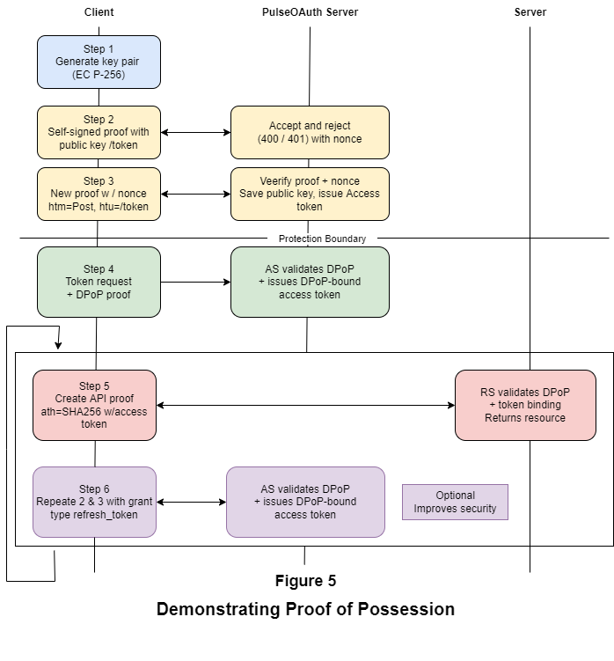

Multiuser, Multiple Agent per User, Flow Diagram
Pulse CA configured with its Reflex endpoint background service is an ideal framework for securing AI agents. Architecturally it provides:
- Background service configured to launch on user login
- On first launch, registers a unique device and configured tenant identifiers
- Verify user’s Pulse CA registration (has installed and registered Auth on their cell phone)

While Pulse CA is effective at securing any type of remote user session, it’s especially so where AI agents are concerned. Each additional user login spawns a new instance of Reflex. Figure 6 shows the protocol flow in a typical single user multi-agent environment. The players in this case are:
- The environment (secured of course)
- The user with necessary access rights and keys
- Pulse CA
  - Cloud OIDC provider service
  - Cloud API service
  - Auth user identity app (cell phone)
  - Reflex endpoint security agent
- A human user (Login)

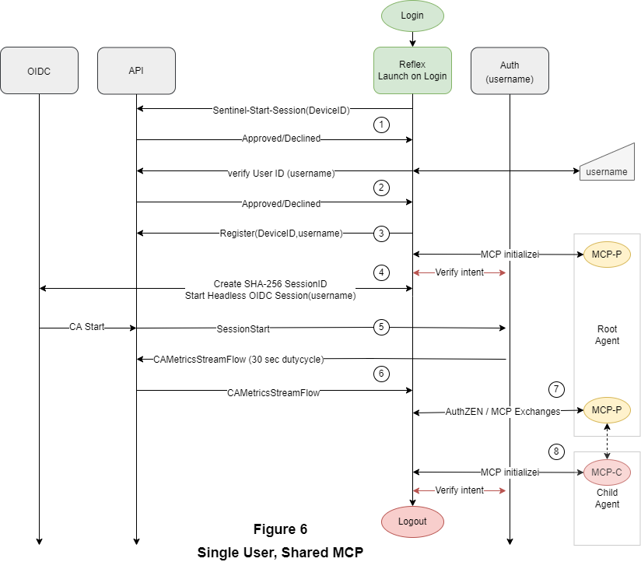
Not shown are user login to the environment using phishing resistant authentication (Passkey or Auth).
- The login event launches the Reflex background service, initialize and begin new session on user behalf
  - Create and pre-register device identifier (DeviceID)
    - On declined, log, report, and terminate
- From user, get their registered username or alias
  - Verify the username provided
    - On declined, log, report, and terminate
  - Establish internal tracking
    - Correlated username to process id
- Complete device registration process and enter idle monitoring mode
  - User spawns Root Agent
- Continuous authentication and identity monitoring begins with delivery of authorization token.
- Within 30 seconds a first set of trust scores are received with notification with updates received every 30 seconds thereafter
- AuthZEN servers are enabled and available for use
In this way, user identity becomes the basis of AI agent identity, an association that extends to agent children as they come and go. Along the way, user verification via cell phone notification continues for each new agent, configuration allowing.

Glossary
Terms used throughout this document. Extend this table as new terms are introduced.
Term | Definition
AAL3 | NIST Authenticator Assurance Level 3 — the highest level of authentication assurance defined by NIST SP 800-63B.
AuthZEN | An OpenID Foundation working-group standard for vendor-neutral, interoperable authorization/access-evaluation queries.
BLE | Bluetooth Low Energy — used by TriNet for active proximity verification.
Commander | The Pulse tenant dashboard used by tenant administrators for configuration, monitoring, and maintenance.
Connect | Pulse's integrated OIDC and SAML provider implementations.
FCM / APNS | Firebase Cloud Messaging / Apple Push Notification service — push-notification channels used for Auth-app messaging.
FIDO2 | A WebAuthn-based standard for phishing-resistant, public-key cryptographic authentication.
FIDO2 DA (Device Assertion) | An out-of-scope application of FIDO2 cryptography that omits the user gesture / user verification step; used for machine-to-machine assertions. Referred to in earlier drafts as FIDO12 DA.
IdP | Identity Provider.
MFA / SFA | Multi-Factor Authentication / Single-Factor Authentication.
OIDC | OpenID Connect — an identity layer on top of OAuth 2.0.
PDP | Policy Decision Point — evaluates trust/context and renders an access decision.
PEP | Policy Enforcement Point — enforces the decision rendered by the PDP.
Pulse API | The cloud orchestration service coordinating all Pulse components.
SAML | Security Assertion Markup Language, version 2 — an XML-based standard for exchanging authentication and authorization data.
Reflex | The optional Pulse background service running on user access devices (Windows, macOS, Linux).
SIEM | Security Information and Event Management — external logging/monitoring destination.
SSDI | Reflex's per-session, per-agent cryptographic session identifier.
SSO | Single Sign-On.
TriNet (Triad Security Network) | Pulse's patent-protected, three-point active-proximity security-assurance architecture, conceptually related to but predating Google's caBLE.
UUID | Universally Unique Identifier — used as the BLE advertisement token in TriNet proximity checks.
WSS | WebSocket Secure — the encrypted channel used between Pulse components and the Pulse API.
DPoP | Demonstrating Proof-of-Possession, refer to OAuth 2.0

